Last Updated: 3/30/15

**Topic Name:** Hibernate

**Brief Introduction:**

When trying to map basic data to a database we have no problem but what happens when we want to map an object to a database? How do we maintain the relationships that an object has and yet keep all the data in the database separated into nice and neat tables separated by what it is we’re sorting? That is where Hibernate comes in.

One of the main purposes of Hibernate is to allow us to map our Java objects into databases in such a way that we maintain the relationships within our data. In Java object we have things like public and private variables and methods. In databases we have carefully planned out tables that keep and store our data for us in a relational manor through having foreign keys. Again, Hibernate allows us to keep those relationships in tacked by mapping.

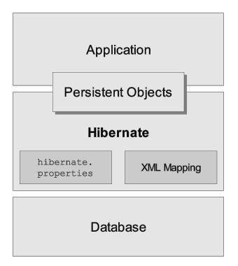

(Image: <http://docs.jboss.org/hibernate/orm/4.3/manual/en-US/html_single/>)

**Teaching Description:**

In my sharing video I talk a little about what Hibernate is but I forgot to mention that one of the main reasons it’s used is for speed on large applications. Normal database querying can take a long time and through hibernate we can get faster results by just allowing Hibernate to do the dirty work for us. In my brief experience with Hibernate however it seems to me that it takes a lot of work in creating the XML file to go along with the Java code, and I wonder if there might be a tool that I haven’t found that would help me write it out more quickly, or possibly just do it for me.

Helpful links:

<http://www.tutorialspoint.com/hibernate/hibernate_quick_guide.htm>

Notes:

1. Make sure that you have your local server running (XAMPP, MAMPP, etc..)
2. Make sure that you look in your NetBeans library and can see that you have MYSQL JDBC Driver mysql-connector-java….. If you don’t have this it is very easy to add. Simply right click the “libraries” folder and choose “add library” and add the driver listed above.

Tutorial Helps:

Use this one to get started with setup:

<https://youtu.be/ddoo6BUz4G4>

Then make the changes to the FactorySession in this tutorial.

<https://youtu.be/gwP8PPhBb1g>

**Teaching Examples:**

My sharing video link: <http://youtu.be/JuuERLQFjHo>

**Files to View:**

Hibernate/CIT360Hibernate_demo